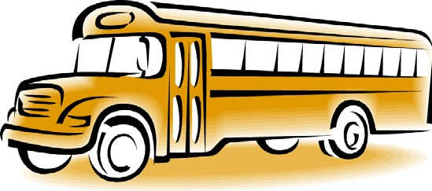

We are seeking students in **Grade 4-6** to take on the role of Bus Patrol Helper.

The requirements for this position are listed below. The Learning Skills and Work Habits you will have the opportunity to build and demonstrate are shown in brackets followed by other words in *italics* that can be used to describe the same work habit.

For example, a coach or volunteer supervisor may have said you are “Reliable” and have good “*Teamwork*” skills. This is like saying you are “Responsible” and a good “Collaborator”. Knowing different words used to describe work habits can help you relate your school experiences to your experiences outside the classroom.

As a Bus Patrol Helper, you will also have an opportunity to build and demonstrate your Essential Skills. These

skills are used in work, learning and life. Essential Skills are shown in **bold** after the work habits.

Overall Responsibilities

• Always wear your safety vest so you can be identified by students and staff. (Responsibility, Organization,

*Reliability, Working Safely*)

• Be a positive role model for all students at all times. (Self-Regulation, Responsibility, Initiative, *Reliability*)

• Read all bus safety rules and be prepared to explain them to other students. (**Reading Text, Oral**

**Communication**)

• Communicate well with other Bus Patrol Helpers, Bus Driver, Staff Members, and students. (Collaboration,

*Teamwork*, **Oral Communication**)

• Assist students, as appropriate, while ensuring your own safety. Always be sure to incorporate your Bus Patrol

Safety Training. (Responsibility, Initiative, *Reliability, Customer Service*)

• Be a good problem solver. For example, a student will not listen and is not obeying the bus rules. Inform the bus driver or a staff member immediately. (Initiative, Responsibility, Self-Regulation, *Reliability, Working Safely, Self- advocacy*, **Oral Communication, Problem Solving**)

• Find a replacement Bus Patrol should you be unable to complete one of your shifts. (Responsibility, Initiative,

*Reliability*)

When you are on the bus …

• Sit in your assigned seat, ensuring that bus patrol helpers are spread out with representation at the front of the bus, in the middle of the bus and at the back of the bus. (Organization, Responsibility, *Reliability*)

• Work collaboratively with your fellow Bus Patrol Helpers to communicate any issues. (Collaboration, *Teamwork*,

**Oral Communication**)

• In a positive and supportive way, remind students to follow the bus rules and to treat each other with respect.

(Responsibility, Initiative, *Reliability*, **Oral Communication**)

• At the end of your bus ride, speak with the Bus Driver and School Staff if there were any concerns. (Responsibility, Initiative, Collaboration, *Reliability, Teamwork*, **Oral Communication**)

• Assist students as they descend off of the bus and allocate at least two bus patrol helpers to the Kindergarten students. (Responsibility, Organization, Collaboration, *Reliability, Teamwork*)

When the bus arrives at school in the morning …

• Ensure that no one gets off of the bus until a supervisor greets the bus. (Responsibility, *Reliability*)

At the end of the day….

• Arrive promptly, at the end of the day, to the bus line-up. (Responsibility, *Reliability*)

• Walk all students to their designated area, paying special attention to the Kindergarten students. Ensure that

one Bus Patrol Helper is at the front of the line and another Bus Patrol Helper is at the back of the line to prevent

any stragglers. (Responsibility, Organization, Collaboration, *Reliability, Teamwork*)

• Assist the teacher on duty, as appropriate, while waiting for the bus to arrive - help students get to the right bus line, remind students to sit quietly and follow the school rules while waiting for the bus. (Responsibility, Collaboration, *Reliability, Working Safely, Teamwork,* **Oral Communication**)

• Once the teacher has given the signal, guide students to the bus and assist them to get on the bus and into their seats safely. (Responsibility, *Reliability*)

You can **transfer** your Essential Skills and work habits to everyday life or the next place you go – whether it’s further education, training or the workplace. More information on how you use your Essential Skills and work habits in everyday life is on the Ontario Skills Passport website.

Identifying and reflecting on the Essential Skills and work habits you demonstrate as a Bus Patrol Helper will help you develop your “All About Me” portfolio as you answer the four education and career/life planning inquiry questions: ***Who am I? What are my opportunities? Who do I want to become? What is my plan for achieving my goals?***

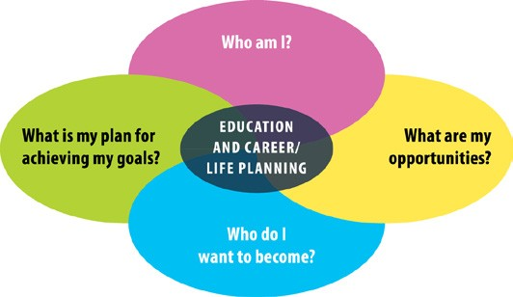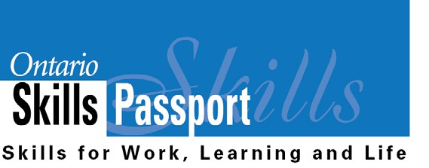

ontario.ca/skillspassport